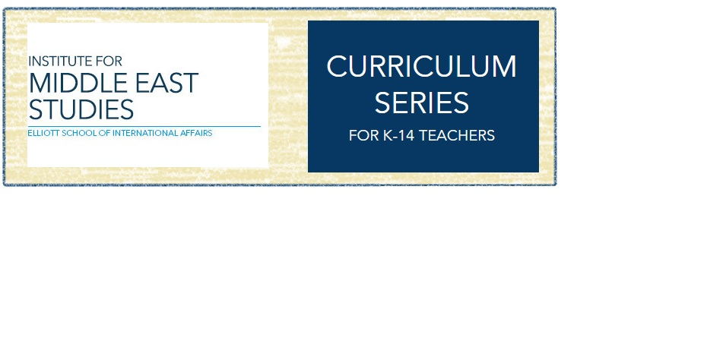

**Hip-hop and the Middle East:**

**A Teaching Guide**

**Contents**

Introduction for the Teacher: Hip-hop as Pedagogy

Lesson 1: Exploring What You Know

Lesson 2: What is Hip-hop?

Lesson 3: Viewing Hip-hop about the Middle East

Lesson 4: Graffiti in the Middle East

Additional Teacher Resources

**Introduction for the teacher: Hip-hop as pedagogy**

Hip-hop is a powerful medium for engaging students as they seek to understand the complexities of the world around them. It is a music genre born in Black American urban communities in the 1970s and has been adopted worldwide as a tool to express a variety of experiences, from mere entertainment to deep political critique. Hip-hop’s scope includes visual, auditory, and movement-based arts, making it appealing to a variety of learners. When hip-hop is used as a lens for understanding and engaging with the modern Middle East, it gives students primary source access to individual stories, social commentary, historical memories, and cultural trends that are relevant and interesting to students.



[→ Click this link to read more about Dr. Youmans and his research](https://smpa.gwu.edu/william-youmans)

**How else can hip-hop be used as a pedagogy or teaching strategy?**

Lessons that involve hip-hop can help make your pedagogy [culturally-relevant](https://www.youtube.com/watch?v=nGTVjJuRaZ8&feature=youtu.be). You don’t have to start rapping with students in the classroom, but if you’re interested in diving deeper into hip-hop pedagogy, check out this quick video of Dr. Peter M. Plourde (known as [Professor Lyrical](http://professorlyrical.com/)), Associate Professor and Faculty Development Specialist at the University of the District of Columbia.

[](http://bit.ly/2DMDEhz)

[→ Click here](http://bit.ly/2DMDEhz) to watch the video on YouTube.

**About This Teaching Guide**

This teaching guide…

* can be used flexibly depending on available instruction time
* is culturally-relevant and engages students in [inquiry-based learning](https://www.edutopia.org/blog/what-heck-inquiry-based-learning-heather-wolpert-gawron)
* follows [K-W-L methodology](http://www.nea.org/tools/k-w-l-know-want-to-know-learned.html) (What do you **K**now? What do you **W**onder? What did you **L**earn?)
* offers engaging, meaningful lessons that address a variety of **interdisciplinary standards** from the [National Council of Teachers of English](http://www.ncte.org/standards/ncte-ira), [National Council for the Social Studies](https://www.socialstudies.org/sites/default/files/2017/Jun/c3-framework-for-social-studies-rev0617.pdf), [National Geography Standards](http://www.educationworld.com/standards/national/soc_sci/geography/k_12.shtml#nss-g.k-12.6) ([National Geographic](https://www.nationalgeographic.org/standards/national-geography-standards/)), [Social Justice Standards](https://www.tolerance.org/sites/default/files/2017-06/TT_Social_Justice_Standards_0.pdf) and [The National Standards for Arts Education](https://artsedge.kennedy-center.org/educators/standards/standards)

**Lesson 1: Exploring What You Know**

**Grade Level:** *Secondary students (Grades 7-12)*

**Standards:**

* **Geography:**
  + **NSS-G.K-12.2** *Places and Regions*: As a result of their activities in K-12, students should understand how culture and experience influence people’s perceptions of places and regions
* **Social Studies:**
  + D2.His.7.9-12. Explain how the perspectives of people in the present shape interpretations of the past
* Language Arts:
  + NCTE.11 Students participate as knowledgeable, reflective, creative, and critical members of a variety of literacy communities.
* Social Justice
  + ID.6-8.5 & ID.9-12.5 Students will recognize traits of the dominant culture, their home culture and other cultures and understand how they negotiate their own identity in multiple spaces.
  + JU.6-8.11 & JU.6-8.11 Students will recognize stereotypes and relate to people as individuals rather than representatives of groups.

**Objectives:**

* + Students will identify some of their existing biases and background knowledge about the Middle East and about hip-hop
  + Students will describe the sources of information that have contributed to their existing notions about the Middle East and about hip-hop
  + Students will be able to define the following vocabulary: *stereotype, connotation, assumption, deconstruct, bias*
  + Students will relate the above vocabulary concepts to their own existing biases in a group discussion format

**Lesson:**

1. Arrange students into groups of 3-4. Give each group a piece of paper (ideally, large chart paper). Ask them to write down words they think of when they hear the term “Middle East.”
2. Next, have the groups flip the paper over and write down words they think of when they hear the term “hip-hop.”
3. After students return to their seats, pass out the “Exploring What You Know” packet.
4. Instruct students to turn to Handout 1 and circle any and every word that they associate with the term “the Middle East.” They can also place an “X” over any term they do not associate with “the Middle East.”
5. Then, instruct students to turn to Handout 2, and circle any and every word that they associate with the term, “hip-hop.” They can also place an “X” over any term they do not associate with “hip-hop.”
6. After students complete both activities, they should answer questions on Handout 3. The questions are designed so that students self-reflect and discover their own existing notions about both concepts before continuing the unit.
7. *Optional*: After students complete Handout 3, distribute Handout 4, “Exploring What You Know: Key Vocabulary.” For each word, select a student who will read the definition out loud while others read along silently.
8. After the definitions have been read aloud, review the word meanings by asking again what each word means (one at a time). Select five students to answer (one student per word).
9. After all words have been read, facilitate a discussion. Ask questions such as:
   * How do these words relate to the activity we just did?
   * Has this activity helped you become aware of any **biases** or **stereotypes** you might hold?
   * How might **assumptions** affect our learning?
   * How can we begin to deconstruct complex things like **stereotypes** and **biases**?
10. Students should save their answers on handouts 1-3 for revisiting at the completion of the unit.

**Exploring What You Know - Handout 1**

**THE MIDDLE EAST**

Circle each term that you think relates. Place an X on any term you think does not relate.

modern religion poverty weak hip-hop education powerful reformed

bad peace intolerant

voice of the people developed traditional exciting culture open women wealth

terrorism innovative scholarly

rights-oriented power unfair

closed

lack of education diverse

limited arts dangerous free

men strong

good violence cradle of civilization conflict progressive exotic

**Exploring What You Know - Handout 2**

**HIP-HOP**

Circle each term that you think relates. Place an X on any term you think does not relate.

modern gangsters poverty weak scholarly education creative powerful white reformed talent bad sexist peace

voice of the people developed traditional exciting culture open empowering wealth education black America

conflict innovative for everyone

role models lack of education

rights-oriented power unfair

for certain people

impressive exciting strong

universal diverse

limited good dangerous

men powerful music

arts violence women

**Exploring What You Know - Handout 3**

1. List all the words you associated with “The Middle East.”
2. Select three of these words. For each, explain what made you circle that word.
3. Have you seen, heard, or read something that influenced your answers? Explain.
4. Look at words you put an X on. Select two and explain why you placed the X.
5. List all the words you associated with “hip-hop.”
6. Select three of these words. For each, explain what made you circle that word.
7. Have you seen heard, or read something that influenced your answers? Explain.
8. Look at words you put an X on. Select two and explain why you placed the X.
9. Look at your lists. Now write down the words (if any) that you circled for both “The Middle East” and “hip-hop.”

**Exploring What You Know: Key Vocabulary - Handout 4**

**Connotation**: an idea or feeling that a word invokes in addition to its literal or primary meaning.

**Stereotype:** a widely held but fixed and oversimplified image or idea of a particular type of person or thing

**Assumption**: a thing that is accepted as true, without proof

**Bias**: prejudice in favor of or against one thing, person, or group compared with another, usually in a way considered to be unfair.

**Deconstruct**: to reduce something to its constituent parts in order to reinterpret it

**Lesson 2: What is Hip-hop?**

**Grade Level:** *Secondary students (Grades 7-12)*

**Standards:**

* **Language Arts**
  + NCTE.9 Students develop an understanding of and respect for diversity in language use, patterns, and dialects across cultures, ethnic groups, geographic regions, and social roles.
* **Geography:**
  + **NSS-G.K-12.2** *Places and Regions*: As a result of their activities in K-12, students should understand how culture and experience influence people’s perceptions of places and regions;
  + **D2.Geo.6.6-8.** Explain how the physical and human characteristics of places and regions are connected to human identities and cultures.
  + D2.Geo.5.9-12. Evaluate how political and economic decisions throughout time have influenced cultural and environmental characteristics of various places and regions.
* **Social Studies:**
  + D2.His.4.6-8. Analyze multiple factors that influenced the perspectives of people during different historical eras.
  + D2.His.15.6-8. Evaluate the relative influence of various causes of events and developments in the past.

**Objectives:**

* After viewing the video in this lesson, students will recognize major societal factors that contributed to the develop of hip-hop culture
* Students will be able to identify the four main elements of hip-hop culture:
* art/graffiti
* break dancing
* DJing or turntabling
* emceeing or rapping
* Students will evaluate hip-hop’s effectiveness in conveying powerful emotions and themes
* Students will predict and hypothesize how Middle Eastern hip-hop may differ from American hip-hip

**Lesson:**

1. As a class, view Video 1 (6:05) about the history of hip hop:

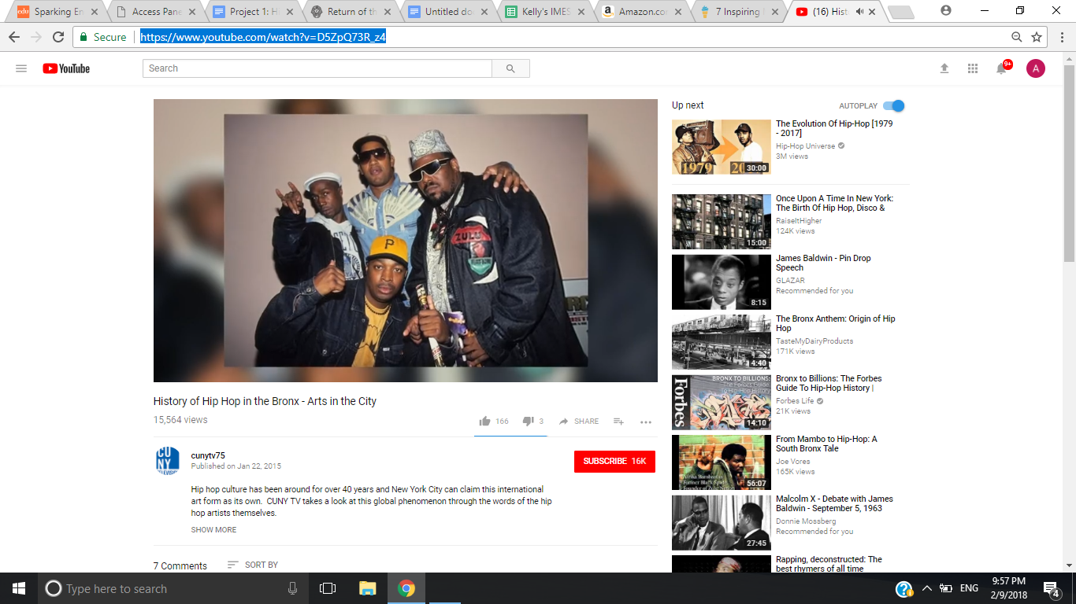

[→ Click here](https://www.youtube.com/watch?v=D5ZpQ73R_z4) to watch the video on YouTube.

2. Ask students the following questions:

1. What factors contributed to the birth of hip-hop?
2. Why do you think hip-hop emerged in an urban context in Black communities in the 1970s?
3. What are the four main elements of hip-hop?
4. Why do so many people across the world use hip-hop as a way to express themselves?
5. How do you think hip-hop in the Middle East will differ from hip-hop in America? What do you think will be similar?

**Lesson 3: Viewing Hip-hop about the Middle East**

**Grade Level:** *Secondary students (Grades 7-12)*

**Standards:**

* + Language Arts
    - NCTE.9 Students develop an understanding of and respect for diversity in language use, patterns, and dialects across cultures, ethnic groups, geographic regions, and social roles.
  + Social Studies
    - D2.Geo.5.6-8. Analyze the combinations of cultural and environmental characteristics that make places both similar to and different from other places.
    - D2.Geo.6.6-8. Explain how the physical and human characteristics of places and regions are connected to human identities and cultures.
    - D2.His.3.6-8. Use questions generated about individuals and groups to analyze why they, and the developments they shaped, are seen as historically significant.
    - D2.Geo.5.6-8. Analyze the combinations of cultural and environmental characteristics that make places both similar to and different from other places.
    - D2.Geo.5.9-12. Evaluate how political and economic decisions throughout time have influenced cultural and environmental characteristics of various places and regions.
    - D2.His.3.9-12. Use questions generated about individuals and groups to assess how the significance of their actions changes over time and is shaped by the historical context.
    - NSS-G.K-12.2 *Places and Regions*: As a result of their activities in K-12, students should understand how culture and experience influence people’s perceptions of places and regions

**Objectives:**

* Students will describe in their own words the themes and messages of four Middle Eastern hip-hop videos
* Students will connect their existing knowledge and biases of the Middle East (from Lesson 1) to videos they view in the Lesson 2 by assessing whether the video affirms, challenges, or problematizes their existing knowledge and biases
* Students will compare and relate Middle Eastern hip-hop to their own cultural contexts
* Students will relate historical trends in the Middle East to historical trends in black American communities by distinguishing similarities and differences in each culture’s use of hip-hop

**Lesson**

1. As a class, watch the following four videos. These videos can also be found as a playlist on the IMES YouTube channel.



[→ Click here](https://www.youtube.com/watch?v=0ISHZQJdeSw) to watch Video 1 on YouTube.

[](https://www.youtube.com/watch?v=lxEr9OTVJ7g)

[→ Click here](https://www.youtube.com/watch?v=lxEr9OTVJ7g) to watch Video 2 on YouTube.



[→ Click here](https://www.youtube.com/watch?v=UjnFbe7D9pY) to watch Video 3 on YouTube.

Be sure to select the “CC” button on bottom of the video for English subtitles.



[→ Click here](https://www.youtube.com/watch?v=J7MHRRcHah0) to watch Video 4 on YouTube.

Be sure to select the “CC” button on bottom of the video for English subtitles.

After viewing each video, discuss the following:

1. Describe the song in your own words. What is the song about?
2. Go back to the exercise of biases and perceptions. Did this song challenge any of your previous ideas about hip hop or the Middle East? Explain.
3. Did the song validate any of your previous ideas on hip hop or the Middle East? Explain.
4. Can you relate the theme of this video to American culture and society?

After viewing all four videos, discuss the following:

1. Make a list of the themes and topics you heard in the four samples of Middle Eastern hip hop.
2. What emotions did you hear conveyed in the songs? What role does emotion play in the power of the music?
3. Recalling what you learned in Lesson 2 about the origins of hip hop in Black American communities, why do you think some Middle Eastern musicians use this music genre to express themselves?

**Additional Teacher Resources:**

* To view a short BBC News Trending video about South Asian migrant worker hip-hop in Saudi Arabia, [click here.](https://www.youtube.com/watch?v=cjn8uOOZ4hg)
* To access the text of the lyrics to the videos, click the following links:
  + [Lyrics to Video 1, “Hamdulillah” by Narcy](https://genius.com/Narcy-hamdulillah-lyrics)
  + [Lyrics to Video 2, “Drunk Shah, Drunk Elder” by Salome MC](http://www.salomemc.com/lyrics/I%20Officially%20Exist%20Lyrics%20(En).pdf)
  + [Lyrics to Video 3, “If I Could Go Back in Time” by DAM](http://www.damrap.com/media/clip/dam-featuring-amal-murkus-if-i-could-go-back-time/162)
  + [Lyrics (and commentary) on Video 4, “Sponsor Song” by Abdulkhaliq](https://www.thegazelle.org/issue/60/opinion/kafeel)

**Lesson 4: Graffiti in the Middle East**

**Grade Level:** *Secondary students (Grades 7-12)*

**Standards:**

* + Language Arts
    - NCTE.4 Students adjust their use of spoken, written, and visual language (e.g., conventions, style, vocabulary) to communicate effectively with a variety of audiences and for different purposes.
    - NCTE.9 Students develop an understanding of and respect for diversity in language use, patterns, and dialects across cultures, ethnic groups, geographic regions, and social roles.
    - NCTE.12 Students use spoken, written, and visual language to accomplish their own purposes (e.g., for learning, enjoyment, persuasion, and the exchange of information).
  + Arts (Content and Achievement Standards)
    - Visual Arts 9-12.1 Students conceive and create works of visual art that demonstrate an understanding of how the communication of their ideas relates to the media, techniques, and processes they use
    - Visual Arts 9-12.3 Students reflect on how artworks differ visually, spatially, temporally, and functionally, and describe how these are related to history and culture
    - Visual Arts 9-12.4 Students differentiate among a variety of historical and cultural contexts in terms of characteristics and purposes of works of art
    - Visual Arts 9-12.5 Students describe meanings of artworks by analyzing how specific works are created and how they relate to historical and cultural contexts

**Objectives:**

* Students will use samples of graffiti in the Middle East as texts and explain how they communicate political messages
* Students will consider how the political context of Palestine and Israel affects the work of graffiti artists
* Students will create their own graffiti art in order to apply the concepts and ideas they learned about hip-hop and the Middle East in order to express their own political message
* utilize the graffiti art form to accomplish their own communicative purposes by sketching and designing their own works of graffiti

**Lesson:**

Remind students that traditionally, there are four main elements of hip-hop culture. Each of these four elements is a different form of expression:

* art/graffiti
* break dancing
* DJing or turntabling
* emceeing or rapping

**Case study: Palestine**

Part One: Learning about the Wall

Nearly 5 million Palestinians live in territories controlled by the state of Israel. The Israeli state was established with UN support in 1948 after decades of Zionist activism to create a national Jewish homeland in Palestine. Since that time, Palestinians have been living in territories now known as the West Bank and the Gaza Strip. Some of these territories are enclosed by giant cement walls. Israel began building giant cement walls in 2002, to separate the Palestinians from Israel, justified by what Israelis consider to be security concerns.

Have students view a short clip explaining this more:

[](https://www.youtube.com/watch?v=PecEVGStsNw)

[→ Click here](https://www.youtube.com/watch?v=PecEVGStsNw) to watch “Israel’s Wall: Security or Apartheid” (3:52) on YouTube.

Questions:

1. Explain in your own words why this wall was built. How long has it been under construction? Is it completed?
2. What is an Israeli explanation for the necessity of this wall?
3. How does the wall affect Palestinians economically, politically, socially, and psychologically?
4. Why would the wall become an ideal place for graffiti?

Part Two: Viewing Palestinian Graffiti

Artists use art to convey meaning and graffiti is no different. Have students consider the following four images of graffiti in Palestine (from this [source](https://vostokzapad.wordpress.com/2010/08/02/israeli-graffiti-4-west-bank-wall/) as well as [this article](http://www.aljazeera.com/indepth/features/2013/11/palestinian-graffiti-tagging-resistance-2013112015849368961.html)):

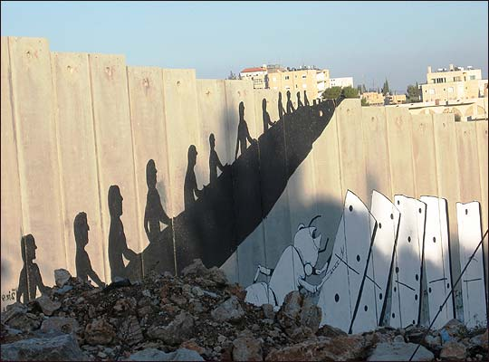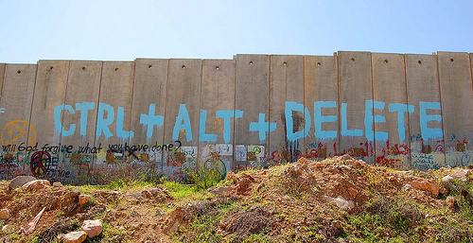

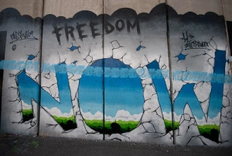

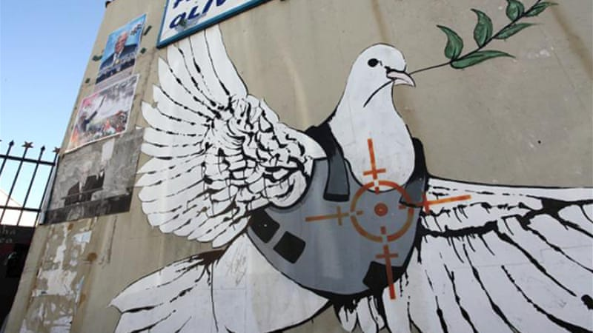

Ask students the following questions about the above four images:

1. What emotions are these images conveying? What messages are being expressed?
2. What do hip hop music and graffiti have in common?
3. How do you think everyday Palestinians who walk past these images are affected by them?
4. Do you know of other “walls” or barriers in other parts of the world that trigger similar political debate?

Part 3: Create Your Own Graffiti

1. Introduce graffiti to students by having them view the following image:

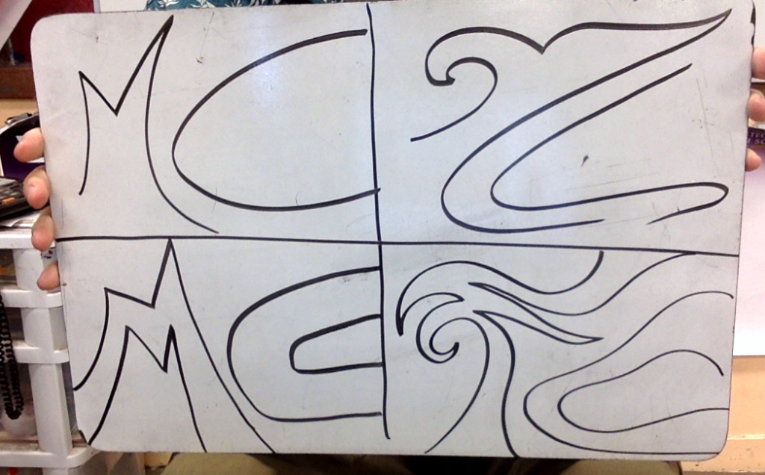

*Source*: Matt Christenson in Art of Education: [How to Implement a Graffiti-Inspired Unit: Week One](https://www.theartofed.com/2017/08/18/implement-graffiti-inspired-unit-week-one/)

2) As students look at the above image, describe that in each of the four boxes, the artist has drawn the initials of their name in a different style.

3) Have students replicate the four styles on their own blank sheet of paper, according to [these instructions by Matt Christenson](https://www.theartofed.com/2017/08/18/implement-graffiti-inspired-unit-week-one/):

* In the first box, explain they are creating “tag” letters. Ask students to stretch one letter to touch the top and bottom of the box with the second letter being smaller.
* In the second box, have students stack one letter on top of the other.
* In the third box, ask students to twist and curve their letters in uncomfortable ways.
* In the fourth box, ask students to make each letter touch all four edges of the box.

4) After students have practiced playing with their initials, distribute [pages 17-20 in the hip-hop curriculum provided by Rhymes to Re-Education](http://www.rhymestoreeducation.com/wp-content/uploads/2013/02/rhymes_online_dual-navigation.pdf), pictured below:



[→ Click here](http://www.rhymestoreeducation.com/wp-content/uploads/2013/02/rhymes_online_dual-navigation.pdf) to access the free Rhymes to Re-Education Hip-Hop Curriculum

5) Follow the steps described in the curriculum. You may wish to omit Step One (Becoming familiar with different styles of graffiti on the internet), since students have already spent time viewing Palestinian graffiti.

6) After students create their own original works of graffiti, ask each student to show the class their work and answer the following:

1. Why did you create this graffiti? What message are you communicating?
2. What connection do you see between the graffiti you created and the lessons you have learned about hip-hop and the Middle East?

Additional Resources For Teaching About Palestine and Graffiti

* The Art of Education: [How to Implement a Graffiti-Inspired Unit - Week 1](https://www.theartofed.com/2017/08/18/implement-graffiti-inspired-unit-week-one/)
* The Art of Education: [How to Implement a Graffiti-Inspired Unit - Week 2](https://www.theartofed.com/2017/08/18/implement-graffiti-inspired-unit-week-two/)
* Al-Jazeera: [Israel’s Wall: Security or Apartheid?](http://america.aljazeera.com/articles/2015/12/17/israels-wall-security-or-apartheid.html) (article)
* PBS: [Lesson Plan: Both Sides of the Fence: The West Bank Security Wall](http://www.pbs.org/pov/thiswayup/lesson-plan/)

**Additional Teaching Resources**

The resources below can be used with or without this curriculum in order to enhance your classroom instruction and/or unit.

* [Rhymes to Re-Education](http://www.rhymestoreeducation.com/) is a Hip Hop Curriculum resource guide. Its goal is to mobilize the power, popularity and potential of Hip Hop culture as a platform for transformative education and re-education. Intended as a resource for both school- and community-based educators, it describes the what, why and how of using Hip Hop as critical pedagogy to engage and activate the hearts and minds of learners ages 7 and up.
* [GET FREE](http://getfreehiphopcivics.com/) is a multimedia Hip Hop civics curriculum for youth and young adults. Its goal is to introduce students to a national network of young community leaders, artists, and activists who advocate for social change and democratic inclusion driven by grassroots organizing. GET FREE is inspired by the exuberance, ingenuity, political energy, resistance, love, and DIY model of underground Hip Hop. Its aim is to push and extend ideas of democracy, citizenship, freedom, community, civic engagement, and intersectional justice
* [Return of the Mecca](http://www.returnofthemecca.com/) enables you to access multimedia from the arts exhibit “Return of the Mecca: The Art of Islam and Hip-hop.”
* “[TedX: The Transformative Power of Hip-hop](https://www.youtube.com/watch?v=vVvaUAddEkg)” (25:01) A TedX video talk by Professor Lyrical that introduces teachers and education professionals to hip-hop culture and how to use it in the classroom. Professor Lyrical says, “Education should not be a one-way, force-fed, pre-determined lecture, right? It should be a two-way street. That’s what we do in hip-hop.”
* [Rebel Music: Race, Empire, and the New Muslim Youth Culture](https://www.penguinrandomhouse.com/books/1199/rebel-music-by-hisham-d-aidi/9780307279972/) by Dr. Hisham D. Aidi. In this pioneering book, Hisham Aidi—an expert on globalization and social movements—takes us into the musical subcultures that have emerged among Muslim youth worldwide over the last decade. He shows how music—primarily hip-hop, but also rock, reggae, Gnawa and Andalusian—has come to express a shared Muslim consciousness in face of War on Terror policies.
* “[TedX: Hip-hop, Grit, and Academic Success](https://www.youtube.com/watch?v=tkZqPMzgvzg&t=1s)” by Dr. Bettina Love. An impassioned TedX video talk that explains how students who identify with Hip Hop culture have been ignored or deemed deficient in schools because of mainstream misconceptions associated with Hip Hop culture. Through Hip Hop, these students embody the characteristics of grit, social and emotional intelligence, and the act improvisation- all of which are proven to be predictors for academic success.
* [**Palestinian graffiti: ‘Tagging’ resistance**](http://www.aljazeera.com/indepth/features/2013/11/palestinian-graffiti-tagging-resistance-2013112015849368961.html), Al-Jazeera news article that describes more about graffiti in Palestine
* [**When Graffiti Matters the Most: Middle East Graffiti**](https://www.widewalls.ch/feature-article-when-graffiti-matters-the-most-middle-east/), an articlefrom the graffiti website “Wide Walls” that showcases different graffiti from the Middle East